Graphical Abstract for

DksA is a conserved master regulator of stress response in Acinetobacter baumannii

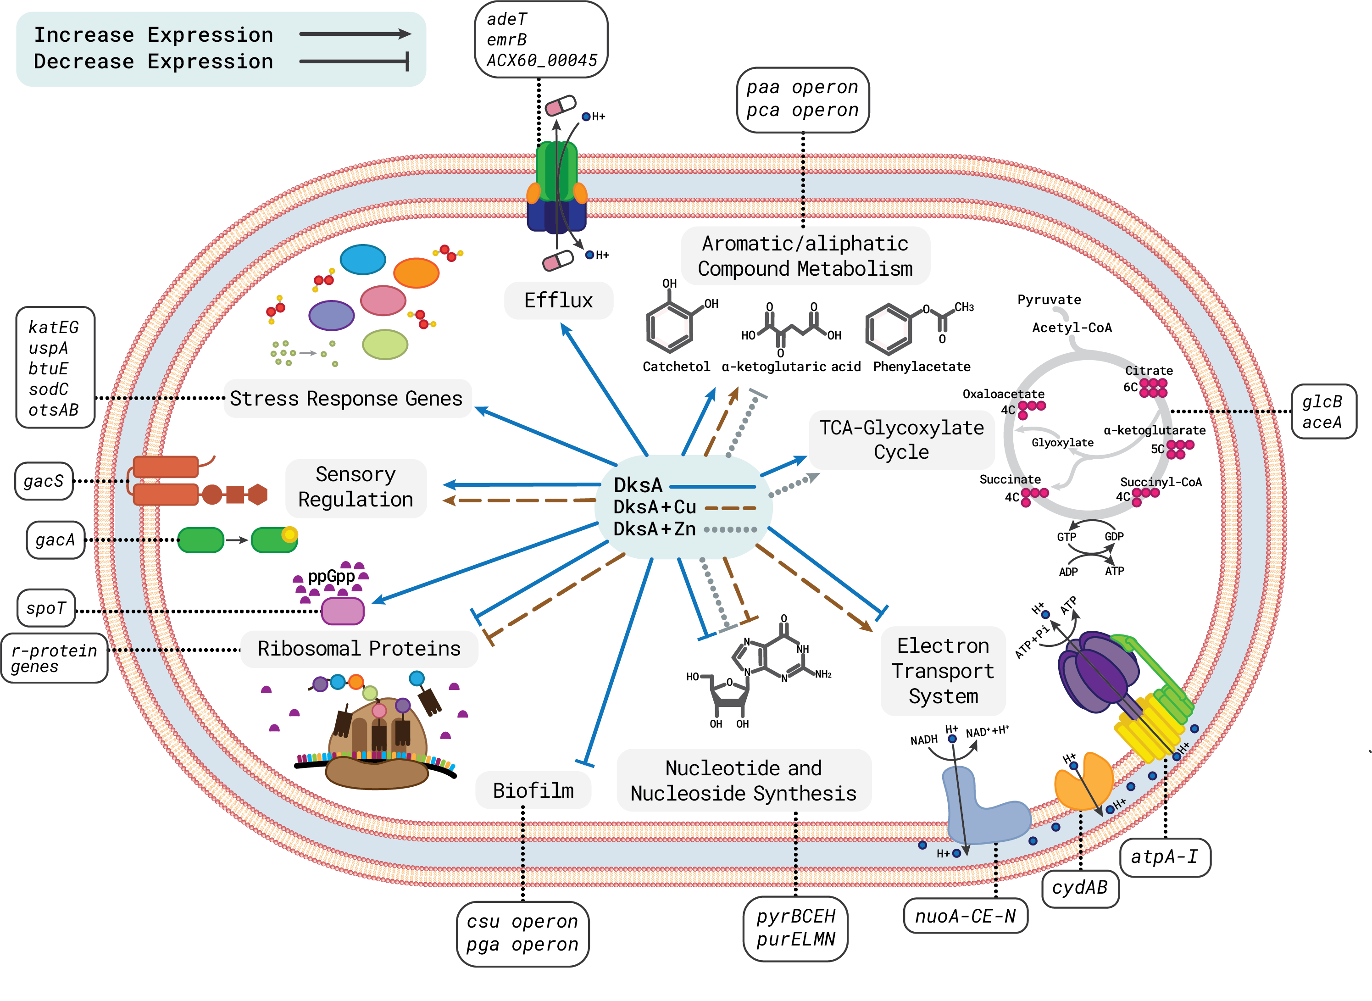
- Bacterial pathogens lacking RpoS such as A. baumannii employs DksA as a master regulator for general stress and metabolism.
- DksA has pleiotropic effects on stress protection and is critical for infection of two animal models in a niche specific colonization manner.
- Activation of DksA is required via a conformational change, but not all stresses activate it.
- DksA is highly conserved than RpoS (over 90% bacteria belonging to Gamma-proteobacteria harbours DksA whereas only 55% harbours RpoS), signifying a broader role of DksA across proteobacteria.

